Photography museum website using bootstrap:

**Memoires and Megapixels**

Contents

Home page hierarchy1

Event page hierarchy1

Join page hierarchy2

Design choice2

Flowchart and site navigation2

References3

Home page hierarchy:

1. Header
2. Carousel + images to draw attention
3. About us information
4. Opening times
5. Location

People looking to go to the photography museum will want to know what the place is, where it is and when it is open so that they can plan an outing or decide whether it will interest them or not.

Event page hierarchy:

1. Header
2. Event jumbotron to introduce key features such as tours, permanent collection and half term events
3. Highlighted event to keep attention and create interest
4. Tours + talks, permanent collection and half-events in one dropdown to show a variety of different things available.
5. Booking and entry information – necessary so people don’t get disappointed if they turn up to the museum and are denied entry
6. Opening times
7. Location
8. Booking form

I chose to place the booking form last so that people who are coming to the website have a chance to find something that interests them, learn about the booking information and to make sure they can reach the museum at the given opening time and location.

Join page hierarchy:

1. Header
2. Introduction to the idea of membership + benefits of joining
3. Registration form
4. Example exhibitions to show what kinds of things members display.

The join page is the lightest page as it will interest the least amount of people. However, it provides examples and benefits that would interest potential members, and offers a means to become a member through the form.

Design choice:

By using a boxy, dropdown heavy site, I can rely on the strengths of bootstrap to create a responsive layout following a given hierarchy. Dropdowns allow me to compact a large amount of information on a smaller space, handy for someone looking to quickly find specific information, or to preserve screen space on a tablet or mobile. My colour scheme uses a triadic colour harmony rule to provide both a pleasing and vibrant style to the website.

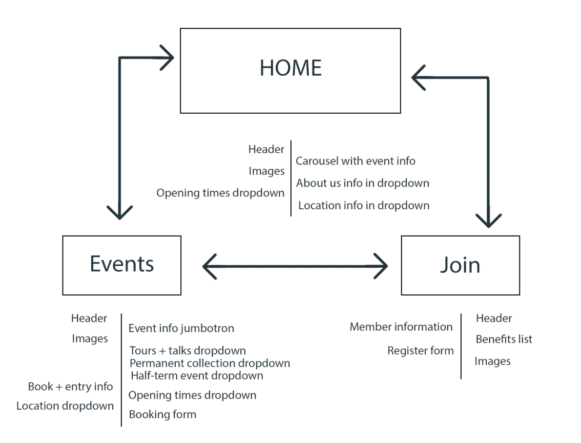Flowchart and site navigation:

References:

All images are taken from Unsplash and are linked below.

<https://images.unsplash.com/photo-1419064642531-e575728395f2?ixlib=rb-1.2.1&ixid=eyJhcHBfaWQiOjEyMDd9&auto=format&fit=crop&w=1950&q=80>

<https://images.unsplash.com/photo-1433838552652-f9a46b332c40?ixlib=rb-1.2.1&ixid=eyJhcHBfaWQiOjEyMDd9&auto=format&fit=crop&w=500&q=60>

<https://images.unsplash.com/photo-1506744038136-46273834b3fb?ixlib=rb-1.2.1&ixid=eyJhcHBfaWQiOjEyMDd9&auto=format&fit=crop&w=500&q=60>

<https://images.unsplash.com/photo-1510936111840-65e151ad71bb?ixlib=rb-1.2.1&ixid=eyJhcHBfaWQiOjEyMDd9&auto=format&fit=crop&w=1367&q=80>

<https://images.unsplash.com/photo-1536146021566-627ce3c4d813?ixlib=rb-1.2.1&ixid=eyJhcHBfaWQiOjEyMDd9&auto=format&fit=crop&w=2134&q=80>

<https://images.unsplash.com/photo-1456926631375-92c8ce872def?ixlib=rb-1.2.1&ixid=eyJhcHBfaWQiOjEyMDd9&auto=format&fit=crop&w=1950&q=80>

<https://images.unsplash.com/photo-1441974231531-c6227db76b6e?ixlib=rb-1.2.1&ixid=eyJhcHBfaWQiOjEyMDd9&auto=format&fit=crop&w=1951&q=80>

<https://images.unsplash.com/photo-1494256997604-768d1f608cac?ixlib=rb-1.2.1&ixid=eyJhcHBfaWQiOjEyMDd9&auto=format&fit=crop&w=1401&q=80>

<https://images.unsplash.com/photo-1561037404-61cd46aa615b?ixlib=rb-1.2.1&ixid=eyJhcHBfaWQiOjEyMDd9&auto=format&fit=crop&w=1350&q=80>